**EbayCrawler User Manual**

**Table of Contents**

**First Use** **-------------------------------------------------------------------2**

**Search by Auction** **-------------------------------------------------------------------4**

**General Information****--------------------------------------6**

**Seller Information --------------------------------------6**

**Image Gallery** **---------------------------------------------7**

**Description****-------------------------------------------------8**

**Search by Keyword****-------------------------------------------------------------------9**

**Search Pane****------------------------------------------------9**

**Category Tree Pane****-------------------------------------10**

**Results Window****------------------------------------------11**

**Search by Previous Results****--------------------------------------------------------12**

First Use

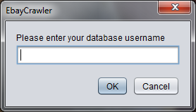

You will first be prompted to enter your MySQL database username

and password. This will be the only time you will need to enter this information.

**Note:** You can always change this information later within the config.txt file that will be in the same folder as your EbayCrawler.jar file.

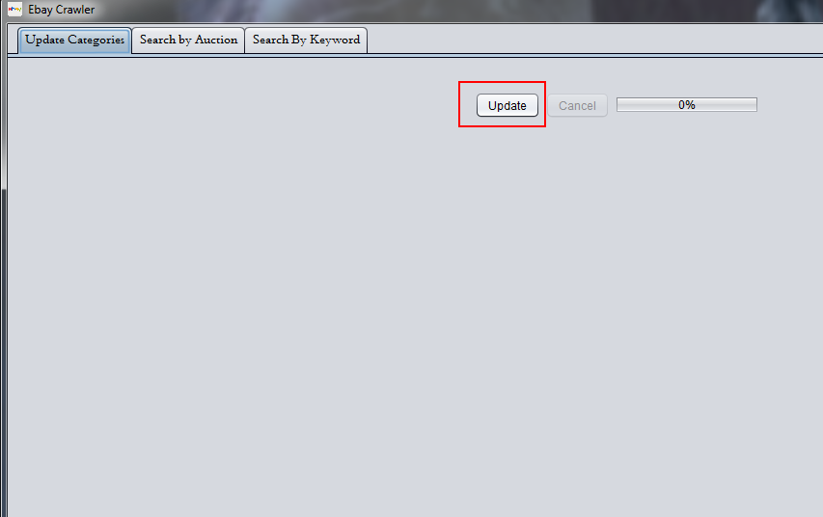

The program will then load and you will be greeted with the Update Categories tab. If you would like the most up to date category listing, you can press update. However, the program comes preloaded with a cached list of categories as of **12/15/2013**.

**Note:** The program cannot run the other functionalities unless you finish updating the categories. The category update function has an average of taking ~8 minutes to execute. Please do not exit the update process in the middle of the process, as this may unset the program’s functionality.

Once the progress bar shows 100% and you are greeted with a finished message, you can then use the other tabs in the program.

Search by Auction

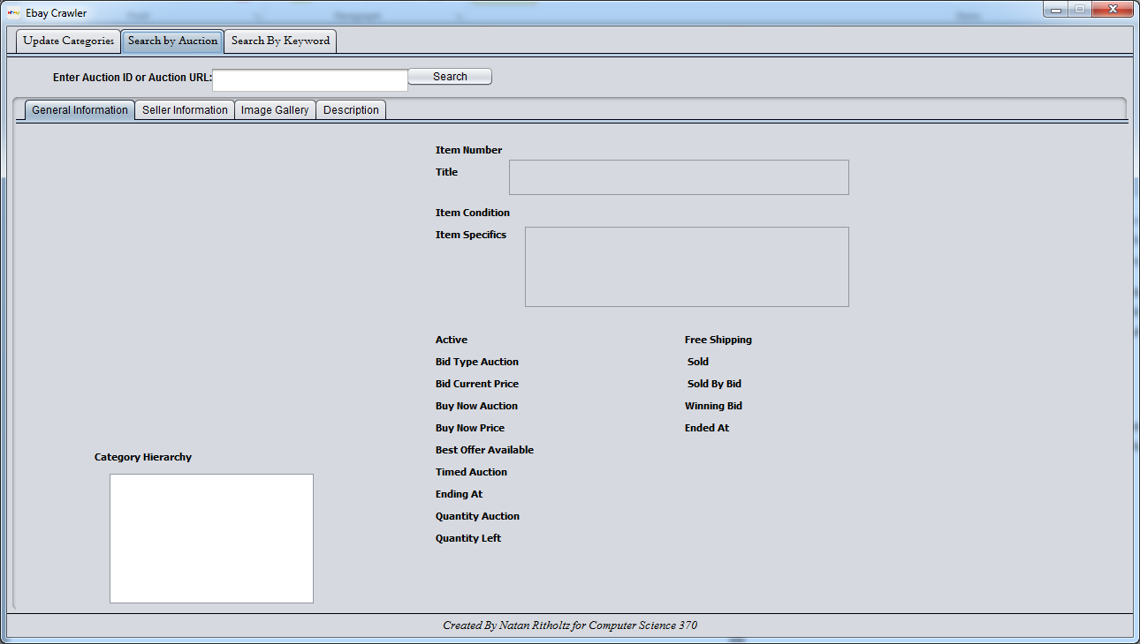

The ***Search by Auction*** tab is a feature that allows you to search auction details by entering either an EBay auction item number or EBay auction URL.

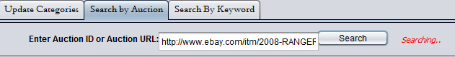

Enter in your item number or URL and then click on the ***Search*** button. The “Searching…” message will appear.

**Note:** Some auctions with a lot of information may take longer to load than others.

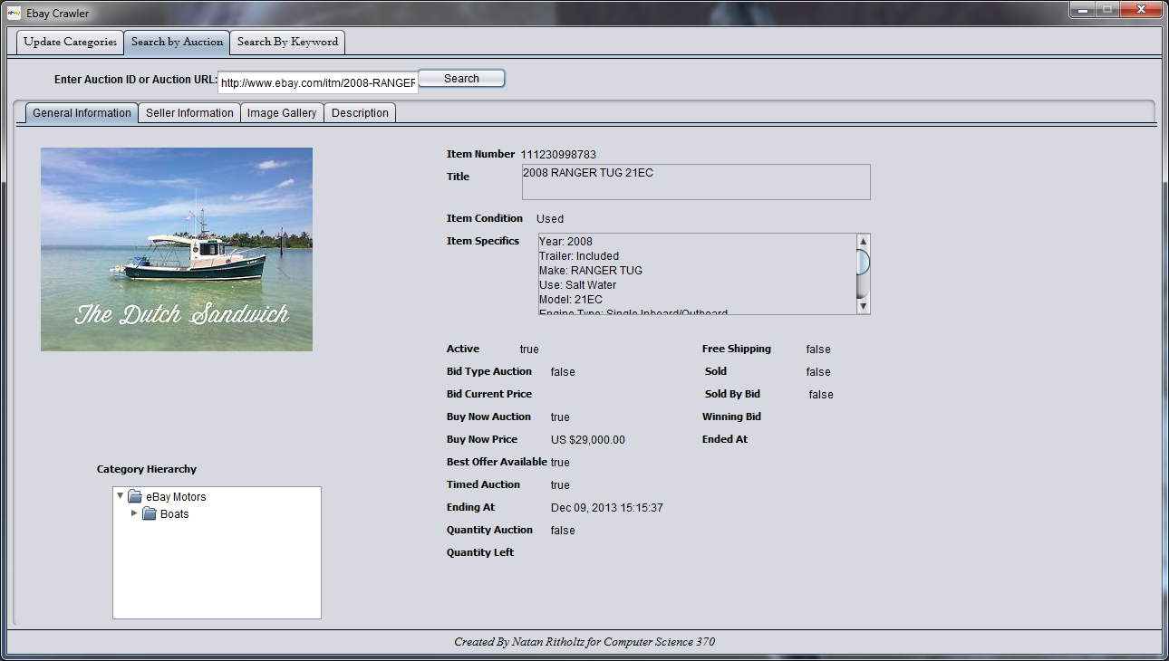

Once finished, you will be presented with information regarding the auction divided amongst four tabs.

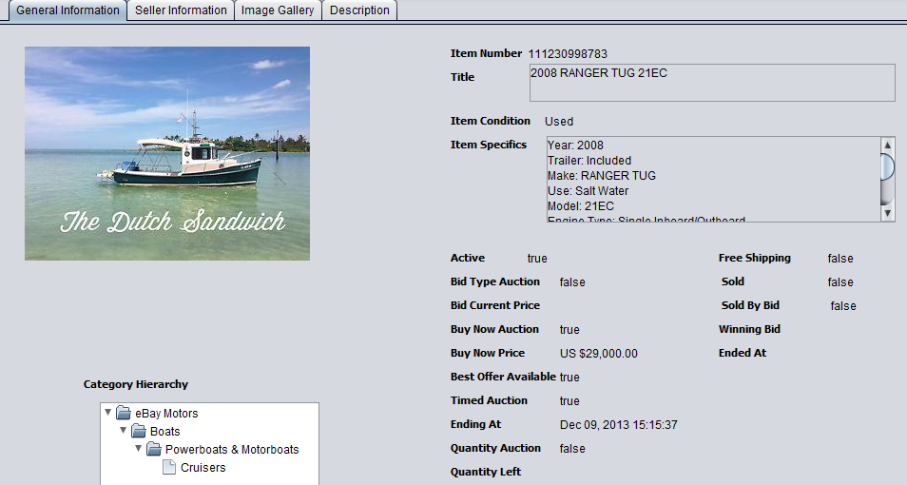

In the General Information tab, you will presented with general information regarding the auction, such as the active state of the auction, its category hierarchy, and item specific details.

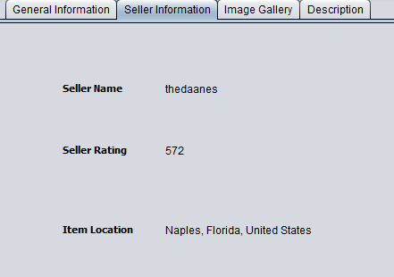

In the ***Seller Information*** tab, you will be presented with information regarding the seller of the item, namely his EBay seller name, rating, and item location.



In the ***Imag******e Gallery*** tab, you can view the images for the item, and click previous and next to cycle through the different photos available.

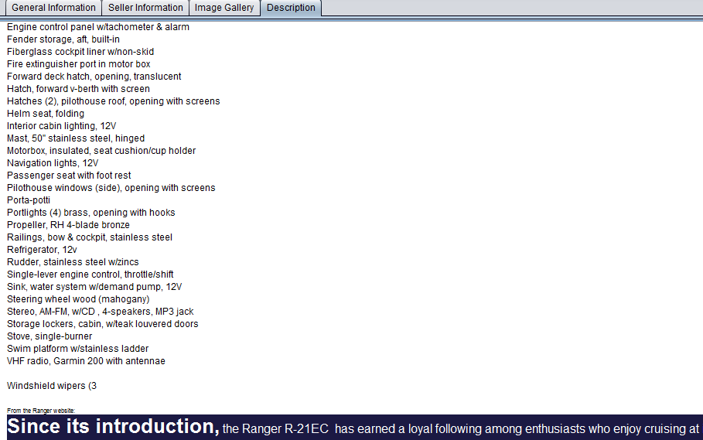

In the ***Desc******ription*** tab, you can view the EBay posted html description as posted on EBay auction page, which may include images and content.

***Search*** ***by Keyword***

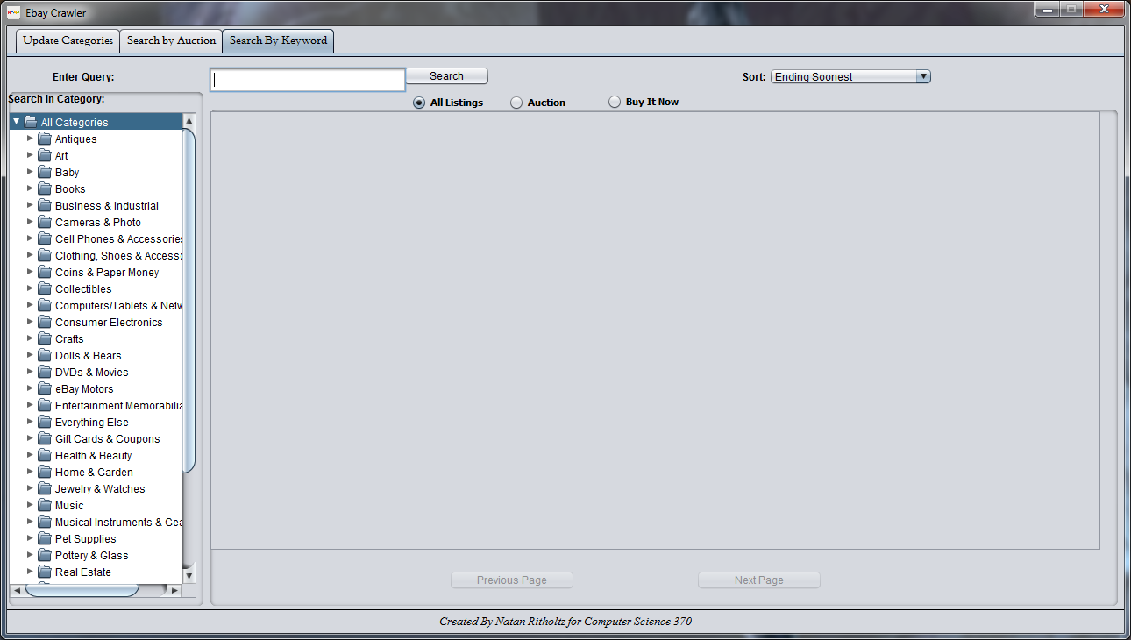

The ***Search by Keyword*** tab is designed to query, by specific keywords and filters, EBay auction listings that can then be selected to open for more detailed information.



In the ***Se******arch Pane***, you will enter the keywords that you want to search for. Then you can also select whether to limit the results to only Auction types or Buy It Now. There is also an option so sort the results by Ending Soonest, Newly Listed, or Best Match algorithms provided by EBay.



In addition, you can limit the search to within a specific category by selecting a category within the ***Categor******y Tree Pane***.

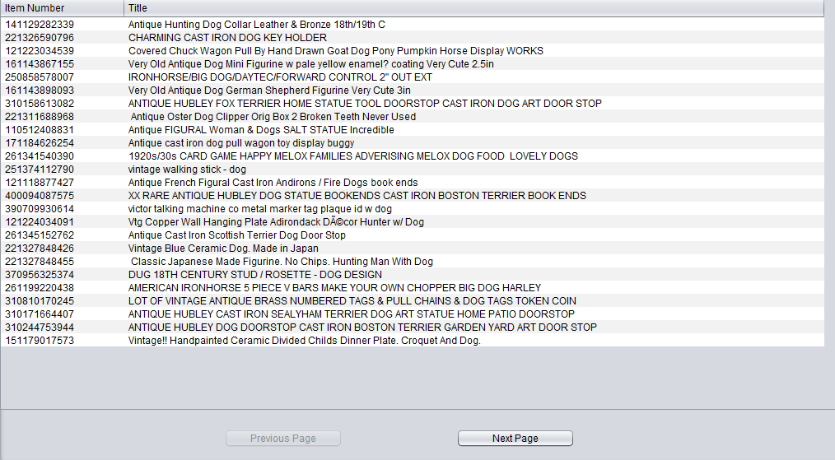

Once you have entered keywords and searched, you will find your results in the ***Res******ults Window***.

Here you will be able to view the results of the query and click on ***Next Page*** or ***Previous Page*** to cycle through the results. In addition, you can **double click** on an auction listing, which will result in the item listing being displayed in full detail within the ***Search by Auction*** tab.

***Search by Pre******vious Results***

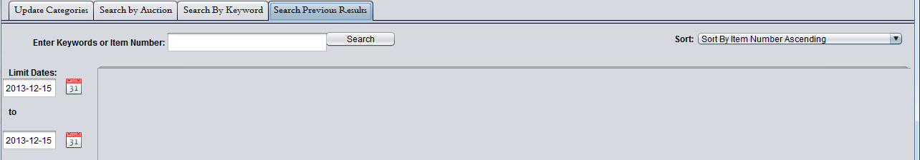

The ***Search by Previous Results*** pane is designed to allow a query of previously searched and itemized Ebay Auctions, sorted by a plethora of filters.

In the ***Search Pane***, you will enter the keywords or item number that you want to search for.

You will also choose the sorting method, whether by item number, title, or time stamp of when the auction information was entered in the database.

Lastly the **Limit Dates** fields are meant to provide a filter of dates for the search, whereby you can click on the calendar icon and select the dates for the **From** and **To** text fields.

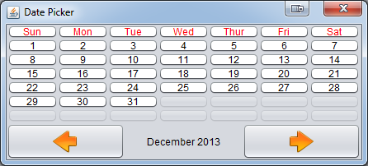

Then you will be able to double click on an auction listing, and be able to view it in greater detail via the auction view pane, as implemented in the Search By Keyword tab.